Clever Badge login flow (grades K-2)

Students who are using Badges will go through the following login flow:

1. They will have the option to choose "Sign in with a different account" or the blue "NEXT" button. They should select "NEXT".

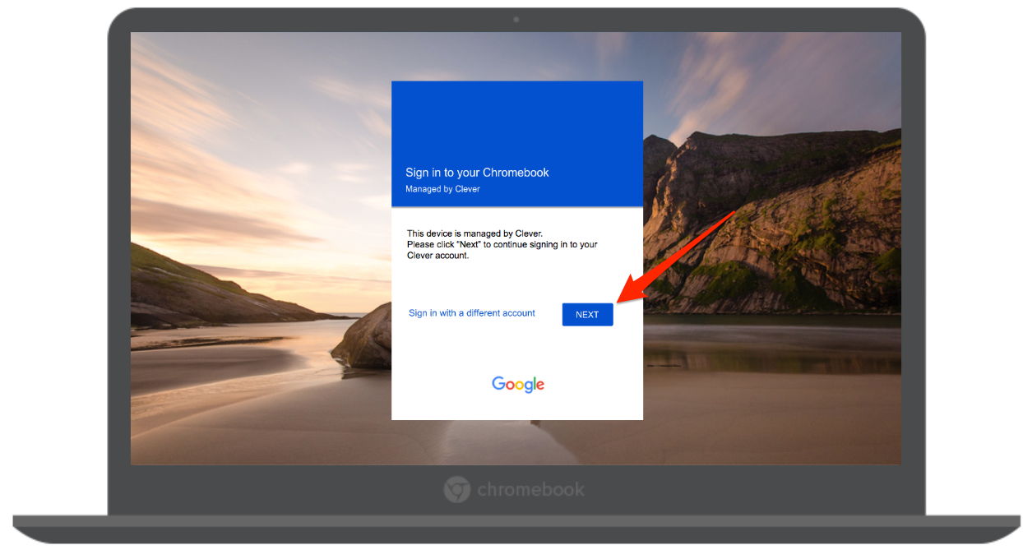

2. Once they select the "NEXT" button, the badge screen will appear:

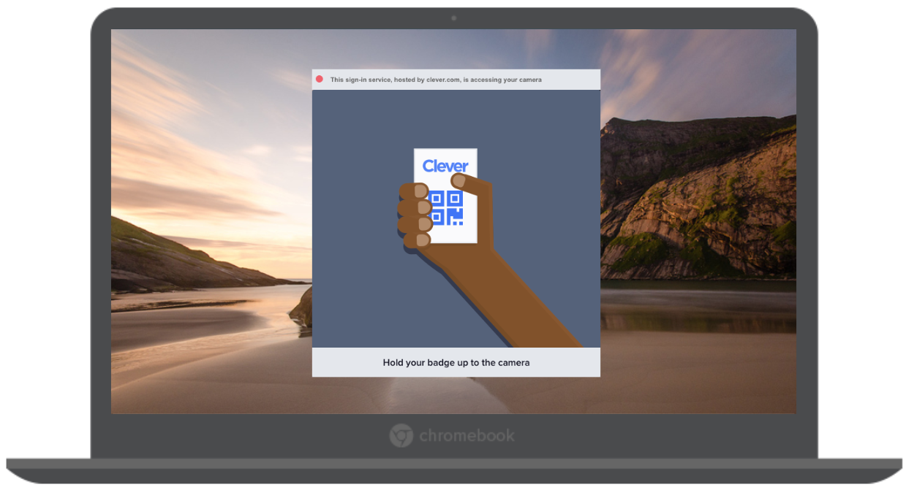

They should then be able to scan their badge, see a green checkmark. Chrome may ask for you to enable the camera.

Once students see the green checkmark, the Clever loading page will appear and the student will be signed into the Chromebook and have access to educational applications assigned to them!

Clever Badge login flow (grades K-2) – using Google login

If your student does not wish to use the badge, they can still use this login screen by following these instructions to login with Google:

1. They will have the option to choose "Sign in with a different account" or the blue "NEXT" button. They should select "Sign in with a different account".

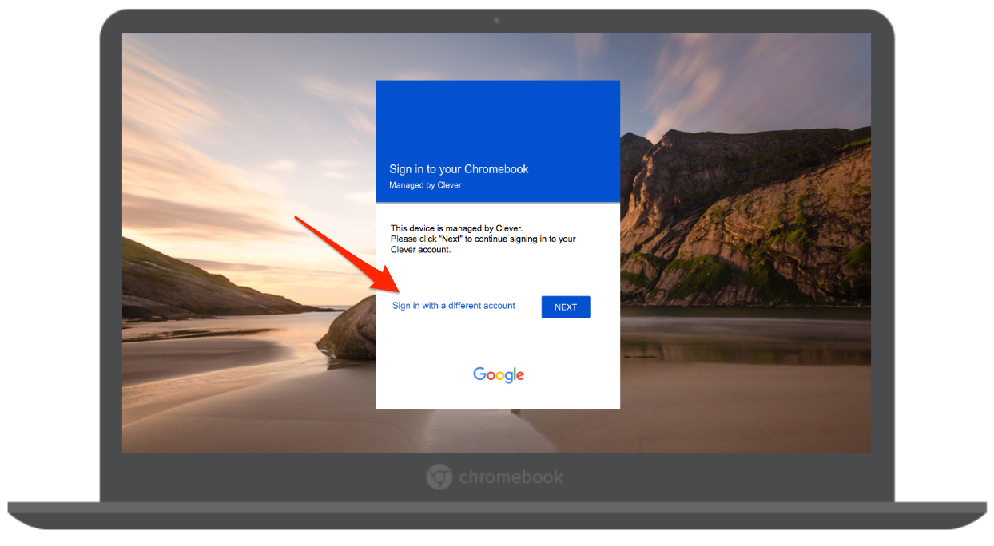

2. Once they select the "Sign in with a different account", they will be prompted by Google to enter their Google email and password.

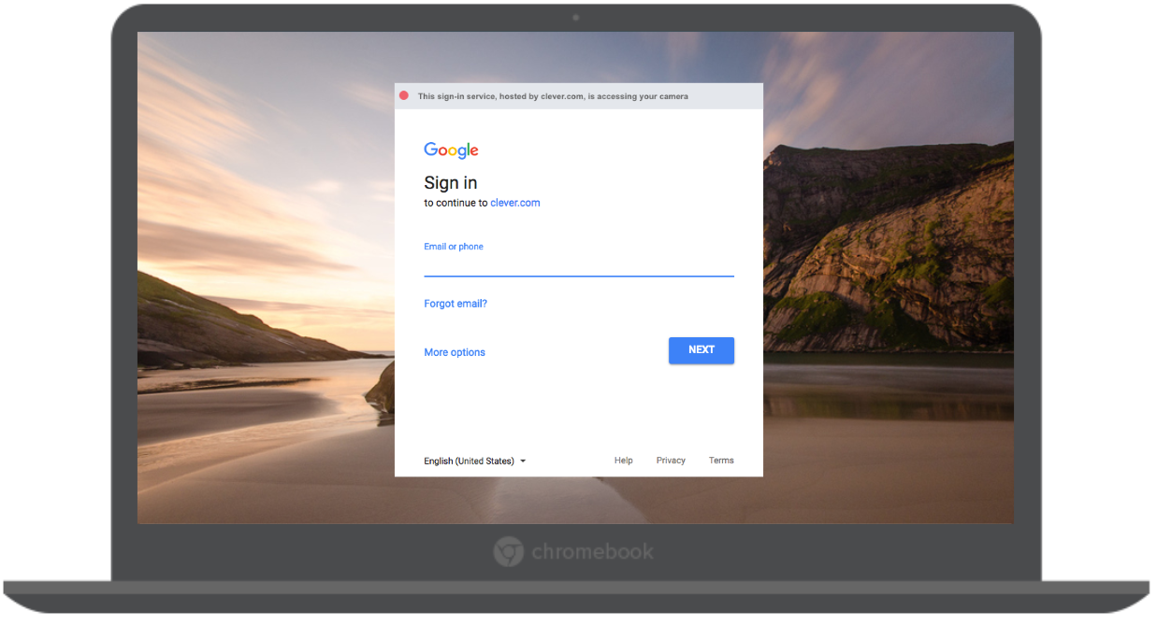

Once they enter their credentials and hit "NEXT", they will be signed into their Chromebooks!